Continuing Server Set Up

Where are my repositories?

In the /etc folder, there is a directory called “yum.repos.d”. When installing any kind of software, the config files in this directory are referenced. To include a new repository, one must make a config file inside the directory, and then add the options necessary to reach the repo within, such as the base id, and a name for the new repository you’re referencing.

Install TMUX/EMACS/Fail2Ban

(Below are screenshots showing each of these being successfully installed/running)

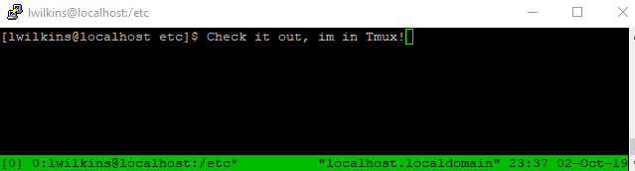

I also installed cowsay and lolcat. I also installed figlet, which allows for *BIG* text.

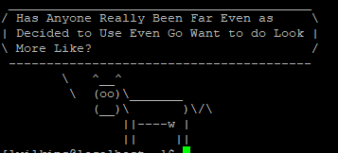

Down below is a shot of me updating vim.

In regards to having a service run on boot, its just a matter of running the following command:

**Systemctl enable *desired service\***

When you wish to stop the service from running on boot, the command is:

**Systemctl disable *desired service\***

We can also list all the enabled services by using:

**systemctl list-unit-files | grep enabled**

Finally, regarding how to boot a system into an emergency mode. In a situation where a hacker might have compromised the system, we can enter into emergency mode, with minimal daemons/processes running, by adding “system.unit=emergency.target”, to the boot config file accessible while the server is initially booting up.

If done successfully, you’ll be greeted by the following screen. From here, repairs/changes to the system can be made.

